Dynamic Fusion of LSTM Predictions Using Reinforcement Learning-Based GOWLA for Human Activity Recognition

ABSTRACT:
Human Activity Recognition (HAR) contributes significantly to vital areas in healthcare, IoT, and smart monitoring applications. Generally, the current models rely on deep learning and traditional machine learning techniques such as LSTM and SVM. However, these methods face considerable challenges, such as imbalanced data distribution, weak adaptation of weights to temporal changes, and a decline in classification performance in rare activities. In this paper, we propose a new method based on dynamic reinforcement learning to update GOWLA weights, which is entitled Dynamic RL-GOWLA. In this method, the LSTM outputs are combined using Weighted Logarithmic Averaging with a reinforcement learning agent for dynamically updating the weights based on the model’s performance in each training iteration. Experiments on WISDM database show that the proposed method outperforms traditional models such as LSTM, SVM, Bayesian Classifier, RNN, and CNN, achieving a F1-score of 96.58%. This approach improves the adaptability of models to imbalanced data, making it a promising solution for tasks that require accurate classification of dynamic human activities.
Existing System:
Most Human Activity Recognition (HAR) systems we currently have use traditional machine learning algorithms (like SVM and Bayesian Classifiers) or deep learning (like RNN, CNN and LSTM). Each of these models is reliant on generally static weights and static learning in their ability to classify human activities with sensor data. These models are effective at classifying common activities but they are less effective for imbalance data distributions and generally not able to account for temporal variations that can exist even within the same activity. In addition, their performance drops sharply when classifying rare or less-frequent activities which are particularly important for healthcare and monitoring applications.

Disadvantages of the Existing System:
- The accuracy of classification for rare activities is low due to the imbalanced development of our dataset.
- By assigning statically fixed weights, we miss capturing temporal changes in activity patterns.
- Deep learning models for example LSTM and CNN, will show a lower F1-score when trying to learn composite, changing activities.
- Traditional deep learning models overfit the continuously occurring classes of activity.
- Our work is hindered when scaling to representing things like more dynamic IoT or healthcare situations with high variability of activities.
Proposed System:
The proposed method in this paper establishes Dynamic RL-GOWLA that combines the outputs of LSTM with Weighted Logarithmic Averaging (GOWLA), where the GOWLA weights are dynamically updated using Reinforcement Learning (RL). Over previous methods, we replace static methods that use defined weights of each of the different sensors with an RL agent that can determine the weights in every training iteration based on the LSTM model’s classification performance. Our technique introduced a dynamic learning agent which can get better at distinguishing activity classification with imbalanced data which is a challenge for HAR. Our system has better classification accuracy, even for rare activities. Because our model is based on reinforcement learning, we can enable self-optimisation and learning of the features during training. By utilizing an RL framework, we are ensuring our proposed model is sound and maximally suitable in real-world applications linked to HAR.
Advantages of the Proposed System:
- F1 score of 96.58%, consistently outperformed existing similar models from Deep learning or machine learning domains.
- The agent learns and dynamically changes weights to recognise time varying dynamics.
- Improved recognition of rare activities, rare activities are instances where supervision or monitoring is needed for health care or the IoT.
- GOWLA, with RL, allows for more uniformity in the signal feature aggregation and reduced chance of, or risk of overfitting.
- has application of use in applicable real-world smart monitoring, health care, and IoT scenarios.
System Architecture:

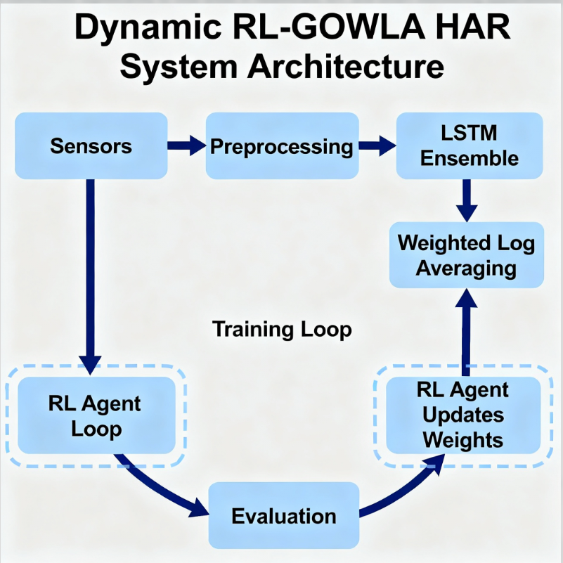

Module Descriptions:
- Data acquisition and pre-processing module:
Human activity datasets (e.g., WISDM) are acquired and pre-processed by cleaning, normalizing, segmenting the sensor's signals, and transforming into structured formats for training.
- Feature extraction module:
Sequential features of the time-series sensor data are extracted. Long Short-Term Memory (LSTM) networks are used to capture the temporal dependencies and patterns of human activities from the sensor data.
- Weighted logarithmic average module:
The LSTM output is aggregated using a weighted logarithmic average strategy with GOWLA; this allows for several activity class predictions to be treated together as a more reliable representation.
- Dynamic reinforcement learning module:
The GOWLA weights are determined dynamically during training through a reinforcement learning agent. The agent learns from feedback regarding the model's performance, such as, whether the agent can optimize the weights only through iterations and across classes of activity to compensate for imbalanced data and rare classes of activity.
- Classification module:
The final, decision making module classifies human activities using the optimized feature representations to maximize the detections success for prevalent and rare activities.
- Performance evaluation module:
The model was evaluated on the WISDM dataset and model performance was evaluated with metrics like F1-score, accuracy, precision. The proposed Dynamic RL-GOWLA method produced an overall F1-score average accuracy of 96.58%, exceeding LSTM, SVM, CNN, RNN, and Bayesian classifiers, respectively.

SYSTEM REQUIREMENTS:
HARDWARE REQUIREMENTS:
• System : Pentium IV 2.4 GHz.
• Hard Disk : 40 GB.
• Ram : 512 Mb.
SOFTWARE REQUIREMENTS:
• Operating system : - Windows.
• Coding Language : python.

FUNCTIONAL REQUIREMENTS:
1. User Module
- User Authentication:
Users must securely log in with valid credentials to access the HAR platform.
- Data Upload and Input:
Users can upload raw sensor data (e.g., accelerometer or gyroscope data) or stream real-time data from wearable devices.
- Activity Recognition:
The system automatically classifies human activities (e.g., walking, running, sitting) using the Dynamic RL-GOWLA model.
- Visualization of Results:
Users can view real-time graphs, predicted activities, and probability distributions of classification results.
- Performance Feedback:
The system displays performance metrics like accuracy, precision, recall, and F1-score for the uploaded data.
- Report Generation:
Users can generate and download detailed reports of detected activities and model performance for further analysis.
2. Admin Module
- User and Role Management:
Admins can create, update, or remove user accounts and assign roles (e.g., researcher, healthcare provider).
- Dataset Management:
Admins can upload, label, and manage datasets (e.g., WISDM data) used for model training and validation.
- Model Training and Optimization:
The admin can train or retrain the Dynamic RL-GOWLA model, adjust hyperparameters, and fine-tune reinforcement learning settings.
- Performance Monitoring:
The system provides the admin with dashboards to monitor training progress, validation scores, and model convergence metrics.
- Weight Adaptation Control:
Admins can observe and adjust reinforcement learning parameters that control the dynamic weight updating in GOWLA.
- System Maintenance and Logging:
The system logs all activities, including data uploads, training sessions, and user operations, for audit and troubleshooting purposes.
- Model Evaluation:
Admins can compare the RL-GOWLA model performance against baseline models (LSTM, SVM, CNN, etc.) to ensure accuracy and stability.

